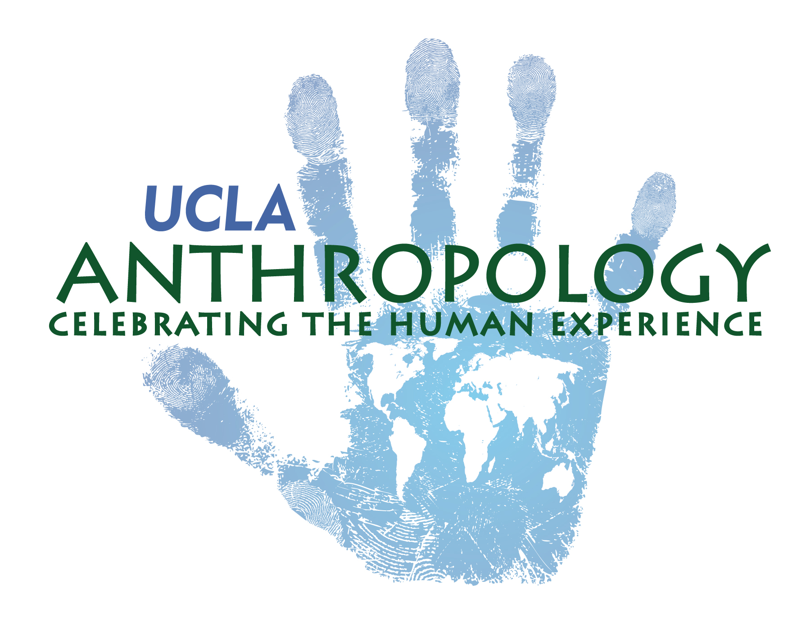
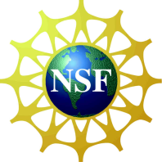
NSF Research Experience for Undergraduates
Ifugao Archaeological Project
Department of Anthropology
University of California, Los Angeles

Letter of Reference Form
To the applicant:
You will need to submit two letters of reference together with your application to the REU-IAP program. Please provide this reference form to your referees and ask them to either submit through email or in a sealed envelope back to you to be included in your application package. Your application need to be postmarked by February 1, 2016. Please fill in your name on the top of the form and provide your referee with the reference letter form (and a stamped, self-addressed envelope should you prefer to mail the reference with your application).
To the referee:
Please return your reference letter EITHER directly to the applicant in a sealed envelope with your signature across the seal OR electronically through email to: acabado@anthro.ucla.edu
For more information on the NSF REU-MASS program, or questions concerning the application process, please contact
Dr. Stephen Acabado
Department of Anthropology
University of California, Los Angeles
Los Angeles, CA 90095
Ph: 310-825-9359
Email: acabado@anthro.ucla.edu

Applicant’s Name:

Referee’s information:

Name: | Title :
Email: | Phone:
University/Institution/Company:
Address:

How long and in what capacity have you known the applicant?
Years/Months:
Capacity:

How would you rate the applicant in overall ability and potential in comparison to others at the same academic level with respect to pursuing undergraduate research? (double click the box to check)
Top 5% Top 10% Top 25% Top 50% Below 50%

Please provide your opinion on the applicant’s academic performance, research aptitude and other factors that you consider relevant for the applicant to be successful in this program and his/her future career including advanced degrees. Provide examples where appropriate.

